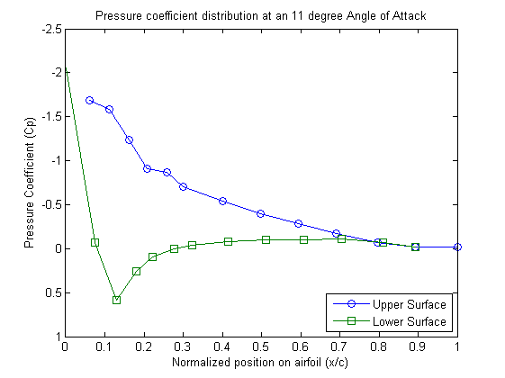

Figure 4.5: Pressure distribution of a NACA 0012 airfoil at

an 11 degree angle of attack.



Figure 4.6: Pressure distribution of a NACA 0012 airfoil at

a 9 degree angle of attack.

Reynolds number

Angle of Attack (deg) 160000 360000

9 0.0203 0.0167

10 0.0188 0.0184

11 0.0760 0.0204

12 0.1340 0.0217

13 0.1520 0.0222

Figure 4.7: Drag coefficient of a NACA 0012 taken at given Reynolds numbers Sandia National Laboratories

Reynolds number

Angle of Attack (deg) 160000 360000

9 0.8527 0.9352

10 0.1325 0.9811

11 0.1095 0.9132

12 0.1533 0.4832

13 0.2030 0.2759

Figure 4.8: Lift coefficient of a NACA 0012 at given Reynolds numbers taken at Sandia National Laboratories

Figure 4.5 is a graph of the NACA 0012 airfoil and its calculated pressure coefficients from measurements taken by the “pressure transducer” at several points around the airfoil. By inspection, the lower surface had an overall positive pressure coefficient versus the top of the airfoil that had an overall negative pressure coefficient. Without any rigorous calculations of the airfoil’s lift, the fact that the pressure on top of the airfoil is less than on the bottom shows that this airfoil does in fact create a lift force at an 11 degree angle of attack. With this in mind, if the lift coefficient produced by this airfoil is more than the calculated drag coefficient, then the airfoil would be able to sustain flight under the right conditions. The right conditions would be if the lift force created by the airfoil is greater than the weight of the object it’s carrying. Actually calculating the lift and drag coefficients from the data collected can help identify if this airfoil actually produces enough lift. In order to approximate the drag coefficient, integrating the momentum deficit created by the airfoil would produce a good estimate. The simplified equation:

$$C_{D} = 2\int_{-∞}^{∞}{\left[\frac{U(y)}{U_{∞}}-{\left(\frac{U(Y)}{U_{∞}}\right)}^{2}\right]\frac{dy}{c}}$$

Since dy, c, $U_{∞}$, and $U_{i}$ is known at every point, this was calculated by a computer program with the equation:

$$C_{D = }\frac{2dy}{c}\sum_{i=1}^{n}{\left[\frac{U_{i}}{U_{∞}}- {\left(\frac{U_{i}}{U_{∞}}\right)}^{2}\right]}$$

The approximated coefficient of drag on the airfoil was calculated as 0.029.

In order to approximate the lift coefficient, a few assumptions had to be made about the lift coefficient equation:

$$C_{L}= C_{n}cos∝ -C_{a}sin∝$$

$$C_{n}= \frac{1}{c}\left[\int_{0}^{c}{\left(C_{p,l} - C_{p,u}\right)}dx + \int_{0}^{c}{\left(c_{f,u}\frac{{dy}_{u}}{dx} + c_{f,l}\frac{{dy}_{l}}{dx}\right)dx}\right]$$

$$C_{a}= \frac{1}{c}\left[\int_{0}^{c}{\left(C_{p,u}\frac{{dy}_{u}}{dx} - C_{p,l}\frac{{dy}_{l}}{dx}\right)}dx + \int_{0}^{c}{\left(c_{f,u} + c_{f,l}\right)dx}\right]$$

Since the NACA 0012 airfoil is symmetrical about it’s centerline and the Reynolds number is relatively small, the skin friction coefficient could be estimated to only effect the drag coefficient, thus can be neglected for the purpose of calculating the coefficient of lift. Also, the axial force coefficient equation plays a small role because the angle of attack is small and will push the sine function close to zero, so this can be negated as well. This leaves the equation:

$$C_{L}= \frac{1}{c}\left[\int_{0}^{c}{\left(C_{p,l} - C_{p,u}\right)}dx\right]cos∝$$

Since c, $C_{p,l}$, $C_{p,u}$, $∝$, and the average value of dx is known, then the equation evaluated by a computer program is:

$$C_{L}= \frac{cos∝dx}{c}\sum_{i=1}^{n}{\left[C_{i,p,l}- C_{i,p,u}\right]}$$

The approximated coefficient of lift on the airfoil was calculated as 0.506.

With both the lift and drag coefficient approximated, the lift to drag ratio is also approximated to be 17.76.

Comparing these results to the ones found in figure 4.7 and 4.8, the individual coefficients differ greatly. Since the lift coefficient data was approximated with such little data, the value could vary greatly and thus giving a wide range of results. The overall lift to drag ratio of this airfoil is a reasonable number for an average airfoil at this Reynolds number.

The calculated Reynolds number in Figure 4.5 was approximately 130,000, which must have been a lower number than the experiment results shown in Figure 4.6. The reason it must have been lower is because the magnitude of the pressure coefficient from figure 4.6 is much lower than that of figure 4.5. Since the Reynolds number is directly related to the free stream velocity and the coefficient of pressure is related by the inverse square of the free stream velocity, the magnitudes in 4.6 will be higher. Also, the experiment in the second figure was done with a 9 degree angle of attack versus an 11 degree angle in the second figure. The results from the first figure are proportional to that of figure 4.6, which gives a good indication that the results found in this experiment are indicative of research that has already been done on this airfoil, thus making it a credible computation.